26 January 2007 The Weekly Bulletin of Rotary Club of Kathmandu Mid-Town Bc # 30 of 2006-07
Rotary Club of Kathmandu Mid-Town
Breakfast Chatter




District : 3290 Web: www.rotarymidtown.org.np Club Id : 26776

JANUARY IS ROTARY AWARENESS MONTH
January is Rotary Awareness Month. Here is a brief/quick Rota-quiz for you. Mark which year each of the following events took place ?
1. When was the first RI Convention in Chicago ? □ 1910 □ 1911 □ 1912
2. When did the The National Rotarian magazine (precursor to The Rotarian) debut? □ 1905 □ 1906 □ 1911
3. When were the first International Rotary Youth Leadership Awards held? □ 2000 □ 2001 □ 2005
4. When was the first club outside the United States chartered? □ 1907 □ 1912 □ 1916
Bonus question: Where was this club?
Answer: 1. 1910; 2. 1911; 3. 2001; 4. 1912; Bonus: Winnipeg, Canada Source: The Rotarian, January 2007

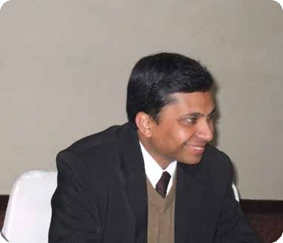

Mr Ranjit Acharya, Chief Executive Officer of Prisma Advertising, while talking to the Club members at the Club's meeting on Friday morning 19 January 2007, provided his concept on Personality Development Basics – a BURNT ACCESS theory.
<--- Ranjit listening to remarks given during a vote of thanks for his presentation.

Weekly Meetings and Programs :
Date | Program/Speaker | Program/Topics of Presentation
26 Jan 2007 | Amanda Rader | RI World Peace Fellowship: One scholar's story
2 Feb 2007 | Dr Narayan Manandhar | Corruption and development
9 Feb 2007 | Buddhi N Shrestha | Border management
16 Feb 2007 | Club assembly | Club assembly

Friday, 26 January :
Ms Amanda Rader will be talking on Rotary International world peace fellowship.
She is the awardee of World Peace scholarship from Rotary International in 2004 and doing her master's degree in peace and conflict studies under the program in University of Queensland, Brisbane, Australia.
She is currently in Nepal doing her 'Applied Field Experience' with Youth Action Nepal, a young NGO working in various aspects of peacebuilding.
After graduating in May 2001, Amanda spent three years serving with the Peace Corps in the Dominican Republic. There she volunteered as a preventative health worker, especially in the area of youth peer education and sexual health.
During her talk she will be providing general background of the World Peace Fellowship, her own story as to how she became a RIWPF and will discuss her experience in Nepal.

Donation of Wheel Chair and Oxygen Cylinder :
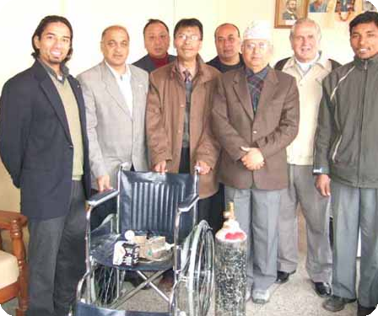
Club President CK Golchha handed over wheel chair, oxygen cylinder and digital blood pressure measuring equipment to Sangha R Shakya, Secretary, Kathmandu District Chapter of Nepal Red Cross Society on Friday, 19 January 2007 in presence of Club members. Secretary Shakya posed for a photo with Club members.

On Lighter Side : Click at the figure ⇩


By simplifying our club leadership structure, we free more of our time, energy, and resources for the real business of Rotary, which is, and always will be, service. By upholding our commitment to our four Avenues of Service, we honor the generations of Rotarians who followed them in the past — and Lead the Way for generations to come.
RI President William B. Boyd

26 January 2007 The Weekly Bulletin of Rotary Club of Kathmandu Mid-Town Bc # 30 of 2006-07

Editor: RR Shrestha, Club Service Director email: rryes@wlink.com.np

